Top Gulf Live Baits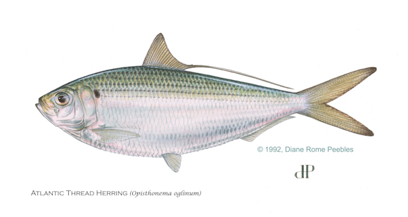
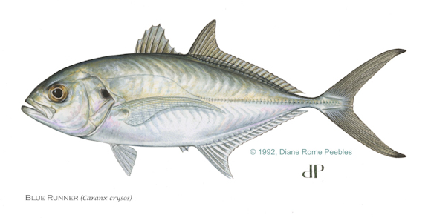
And Crabs, Pass Crabs, small Blues
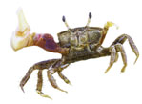
Top Inshore Live Baits
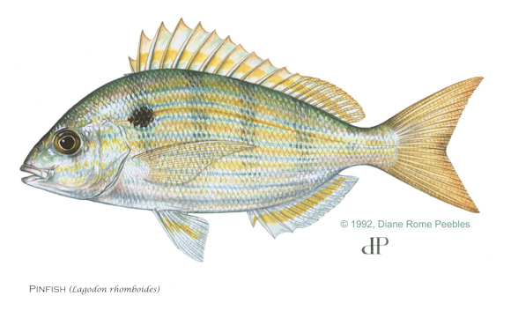

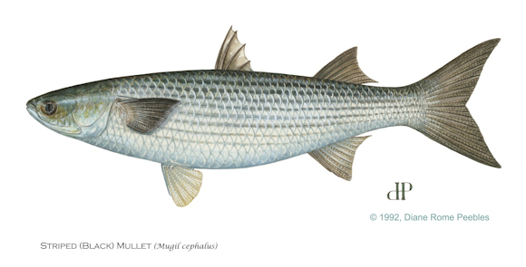

Other Live Baits that Catch Tarpon
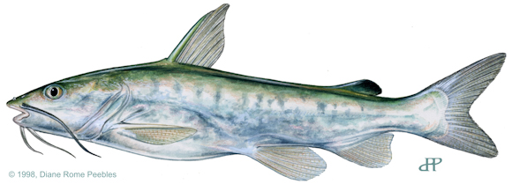

Clip the catfish fins as you would normally and put them out!

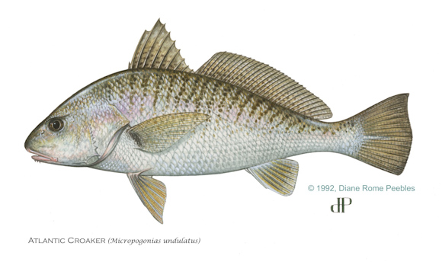

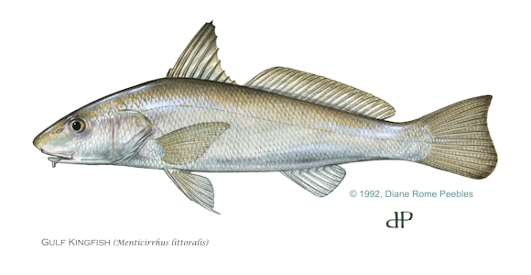

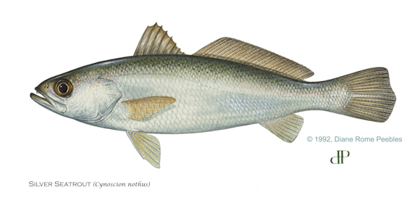
Use a sabiki and if you are catching a bunch of these, throw them back out and hold on. They do not last long as live bait. Keep an eye on them.
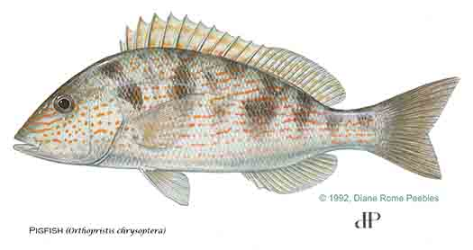
Oinkers bring them in! All Porgies are good.

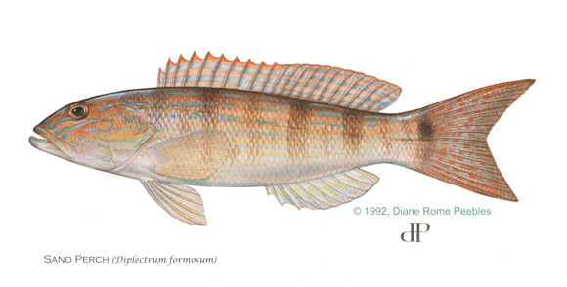
Great eating if you get a bunch of nice ones. Tarpon LOVE ‘em.
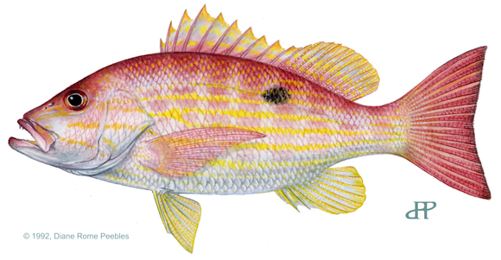
Most people would not fish a legal Lane as bait, I would.

