Rookie Guide for Cape Coral Tarpon Hunters Club
(Updated Feb 1, 2023)
Introduction:
This guide is intended to benefit any rookie member of the Cape Coral Tarpon Hunter’s Club and to allow him to understand the full and systematic method by which the Club members usually fish for tarpon. The authors intend it to be as complete as possible and to include all aspects of tarpon fishing that they have collected from the Club’s most experienced and successful members. Ralph Yost
Official Catch:
Must be caught by a member current in dues and good standing. Must be released within club boundaries and in compliance with Florida’s fishing regulations. Must be hooked by one person to be an “official” catch, credited to an angler’s total. Once the hook has been set, no person other than the person setting the hook may touch rod, reel, or line until the leader has been physically touched by the angler or another person. At that time the fish will be considered “caught” and may be handled by any person to facilitate tagging, and releasing in a manner that would maximize the survival chance of the fish. Fish caught on unattended poles on which the drag is engaged, or in gear, while unattended will be considered “hooked” by the first person to touch such pole. Fish must weigh at least 50 pounds to be eligible for any awards. To estimate fish weight, this formula is to be used: Girth squared, times length, divided by 800 equals the approximate weight of the fish. (A chart is provided in new member packets to assist in the computation of tarpon weight.) All fish release claims must be witnessed to be eligible. It is the club member’s responsibility to furnish the name and contact information of the witness in addition to the catch data including date, time and location of release, estimated weight of the fish, Captain’s name, bait used, and YTD releases. The information shall be provided to the Club statistician by email or other designated electronic means within four days or the release is disqualified.
Reality Check:
An excellent release to hookup ratio is about 40%, only obtained by serious, dedicated and experienced tarpon hunters. Do not become discouraged if you don’t get an official catch on the first few hookups. Tarpon are difficult to find, difficult to get them to bite, and really difficult to get them to the boat for a leader touch. If it was easy, everyone would be doing it.
Boat:
A wide variety of boats can be used to catch tarpon. A preferred size is 21-25 ft. which will allow you to fish in a wide range of wind and weather conditions. Your choice of boat depends on how you intend to use the boat. Florida bay boats are common. You will need a boat large enough to accommodate your large bait cooler and a bait cutting table. A live well is also helpful if you intend to use catfish.
One feature that is desirable to have on your tarpon fishing boat is a T-top or hard top to provide shade from the intense Florida sunshine.
Most Club members anchor up to fish. If you are selecting a boat, consider ease of setting and retrieving the anchor. You will need a reliable anchor and a minimum of 100 ft of anchor rode as well as a sufficient amount of chain attached to the anchor. More than 5 ft of chain will help ensure better and quicker anchor sets in more varied conditions. In general, because of many fishing areas with hard bottom, you may prefer an anchor 1 weight size up from that recommended for your boat length. It is also helpful to mark the anchor rode with length markers every 10-15 feet or so that you can accurately measure your rode as you deploy it.
It is desirable to fish with up to six rods. Therefore, your boat should be configured to be able to handle as many rods as you will be using. It will be beneficial to have more rod holders than is planned to be used so you can spread out the rods when the boat lies broadside to the current (as when the wind effects the boat angle at anchor). Having rod holders installed from the stern to the bow should allow the lines to be spaced sufficiently to prevent tangling. Depending on the boat configuration, one rod holder may be needed to hold a bait table.
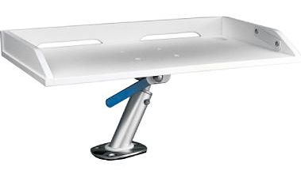

Poles, reels and rigging; Fishing cut bait on the bottom:
The standard recommended poles are 8 foot long, robust fishing poles that will accommodate level wind reels. Poles with a line rating should be in the 50 lb weight class. Eight foot is recommended in order to provide a long length of pole to reach underneath your outboard motor when a fish runs under the boat. A long pole also helps cast farther.
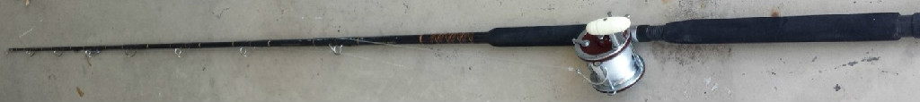

The reel most favored by experienced Club members is the Penn 4/0 Senator 113H. Other reels can be successfully used and there are a number of fine reels manufactured today that both cast well and have proper gear ratio. The Penn 113H is favored for several reasons: the gear ratio of 3.25:1. It holds 270 yds of 50 lb test monofilament line. One spool of Berkely Trilene 50lb test provides the right amount of line for the reel if you are spooling it yourself. No guessing if you use one spool per reel.
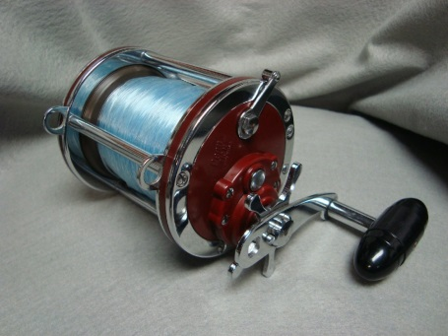
Large spinning reels can be used as well. The reason the spinners should be large is that they need to accommodate a lot of line. Regardless of the reel you choose, your reel needs to hold 250-300 yards of line.
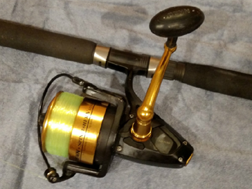
Penn SPINFISHER V Model10500 with 250 yds of 50lb mono.
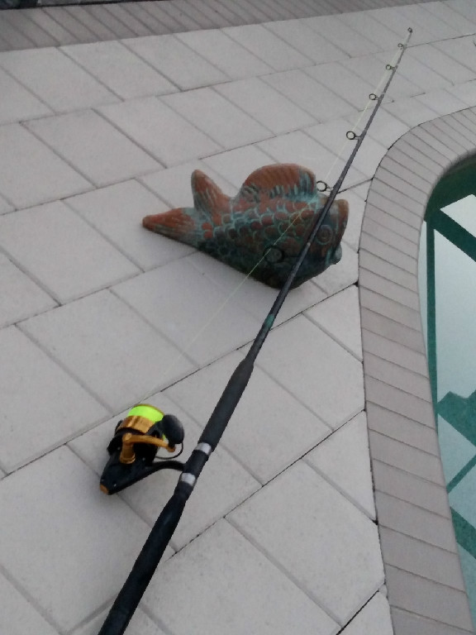 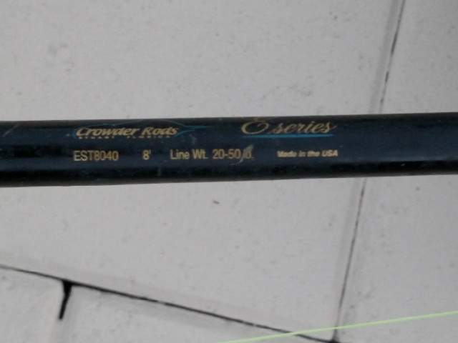
8ft one-piece 50lb class spinning rod
Drag Setting:
For both types of reels the nominal drag setting should be at 1/3 the breaking strength of the mono (about 17 lbs for 50 lb test mono). Braid requires a much lighter setting since it does not stretch. In close quarters or fishing the bridges, reel drag should be set tight….”locked down” with about 20 lbs of tension. For the Penn 113H reel with star drag, that setting is generally achieved when the star drag is tightened fully. You should not be able to pull line off the reel without significant effort. Tarpon have very hard mouths and when they get hooked, you want to ensure a solid pull of the hook into the fish on the initial hooking.
Terminal Tackle:
Use a 6-foot leader of 150 lb test monofilament line. Suggested leader material is TrikFish or Ande. Tie a barrel swivel to one end (Rosco Barrel Swivel 2/0, 225 test) which will be tied to the 50 lb mono reel line. The other end of the leader you will use a Mustad Hook Circle Hook #39960D 14/0 (they sell for about $41 per 100 in a box). These hooks often need sharpening right out of the box. The sharper the point, the better your release to hookup ratio.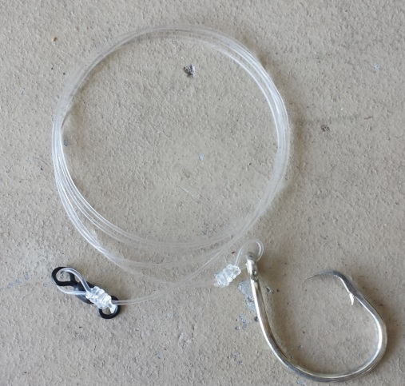
The knot recommended to attach the swivel and the hook is tied with a knot tying tool (large size).
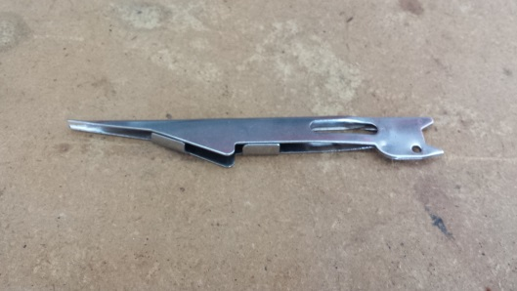
CLICK ON THIS LINK TO SEE A HANDS-ON DEMO OF TYING THE CORRECT KNOT
https://youtu.be/bXKIwPTz2PM
Use ¾ oz or 1 oz weights crimped onto the leader. Place the weight at the top of the leader.
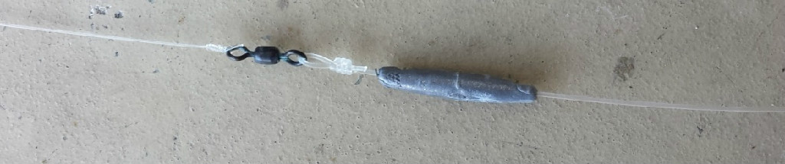
Be sure to have plenty of spare leader-hooks rigs made up in advance and with you on the boat. You will use up leader-hook rigs for a variety of reasons but especially when you catch a shark or ray. You will either cut the leader or if you can get the hook out, the leader may be chafed and unusable (and therefore unreliable) and must be replaced.
Poles, reels and rigging; live bait with a float:
You can use braided line on the spinner which really helps to cast longer distances. If using braided line, 65 lb test is recommended which should provide about 300 yards of line on the reel. The reels and rods should be of enough capacity to put significant pressure on the fish; i.e. not your typical light tackle rigs more suited to redfish/trout.
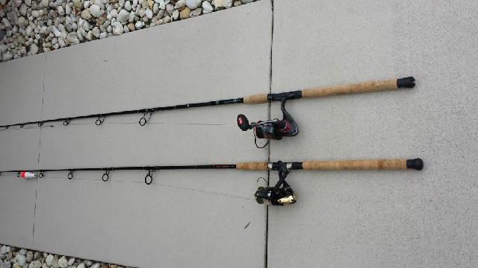
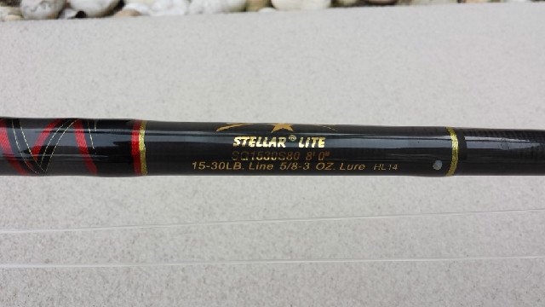
Fishing tools:
Two large bait knives substantial enough to cut through whole mackerel, mullet and catfish will be required. A 20” bait table will be needed to cut your bait. One knife should be a serrated edge blade which cuts through the bait fish well. A 15-minute kitchen timer can be helpful to remind you to check your baits.

Other tools that are needed are large pliers, sharp edge wire cutters (side cutters or linesman pliers), and large needle nose pliers.
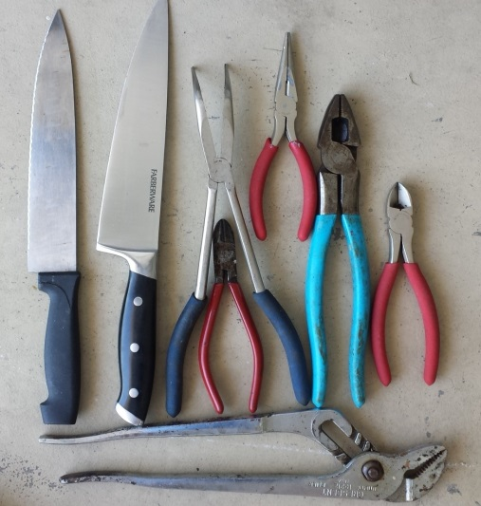
Other Gear:
A good pair of gloves is necessary to be able to grab the leader when the fish is at the boat. The gloves will protect your hands from the edges of the knots on the leader.
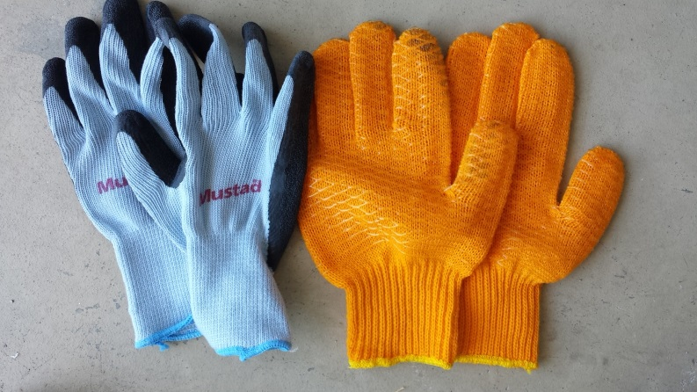
It is advisable to have a fighting belt readily available to put on as soon as the fish is hooked up. The fighting belt will help save the pressure points on your body applied by the butt end of the fishing pole when fighting a large tarpon. You would be wise to provide your own fighting belt as your host may not have one or will be using his own.
It is recommended you provide your own life jacket as your host may not have one that you will wear all day. An automatic inflatable jacket is a good choice.
U tube video of tackle and fish handling:
https://youtu.be/zd6o6wkt76U
Bait:
The baits commonly used for tarpon fishing are large chunks or steaks of mackerel, mullet, and catfish. Live bait can include thread fins, ladyfish, small catfish and pinfish. The most common technique used is cut bait fished on the bottom. Other members fish with live baits drifted or under a float. Some members use a combination of both techniques depending on conditions.
At the end of the tarpon season, many Club members shift into bait mode and start fishing for bait. The mackerel runs can start in October and can be often found off the tip of Sanibel in 6-10 feet of water. Experienced Club fisherman use freezers to store their mackerel catch in the fall and winter which they will use the following season. They place each mackerel in a plastic newspaper or grocery bag to prevent it from sticking to other fish when placed into the freezer. Many Club members use two large freezers to store their mackerel which gives you an idea of how many are needed for the coming season.
Mullet can also be frozen and used in the future. During the season, mullet can be purchased from local seafood wholesale houses.
Mackerel is a commonly used bait and works well for tarpon. However, other fish especially sharks, also like mackerel.
Changing cut baits is important during the fishing day. The current washes through the bait rendering it useless in about 15 minutes. Catfish last longer than mackerel and mullet.
During the season, Club members often fish for catfish. They keep them live at their home docks in large drum containers (like a 55 gallon drum with many holes in the sides to allow water flow). Catfish are sometimes a preferred bait because it lasts longer and is not as desired by sharks, rays, and other unwanted fish.
Cut your bait into steaks about 2-3 inches wide.
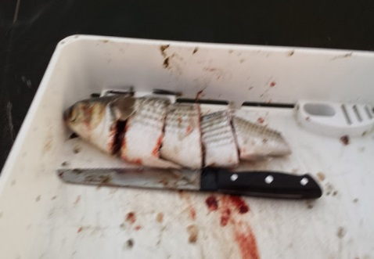
Put the hook into the meat and out the top through the skin. Tarpon are large fish and can consume large baits.
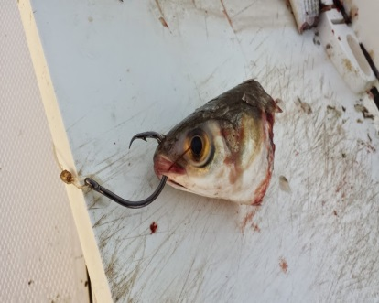
Because you will be changing baits every 15 minutes, and you may have as many as 5 or 6 lines in the water at once, you will need a lot of bait. You should plan on as using much as 15 mackerel and/mullet/catfish if you are fishing with cut bait. Your actual bait usage depends on many factors including how often the trash fish take your bait.
Live bait: Some fishermen use balloons to float live bait near the surface. The technique works well to hold the bait up but broken balloons are bad for the sea life. Turtles can eat them and die from them. Only Styrofoam floats should be used. Live bait can be used effectively to catch tarpon either on the surface or on the bottom.
Mackerel Fishing:
Best baits, trolling or casting for Mackerel:
https://www.outdoorlife.com/gear/best-lures-for-spanish-mackerel/
Use 30 to 40 lb mono when trolling for Macks, no wire required. Watch the leader for chaffing.
If using wire, then you can attach to the wire leader by tying a haywire twist, or, by using small crimps:
https://www.youtube.com/watch?v=O02efF9Q2yw&list=PLIpC9IkQTr-cEvYoATeMPemLzl7Yxr2FI&index=2&t=15s
When using trolling weights with mackerel lures, it’s a good idea to paint them black. A shiny silver lead weight can attract the macks who will attack it and bite ahead of the weight, which will cut your line. By painting the weights black, you can help ensure the macks only attack the lure.

Live Bait Fishing:
How to catch smaller live baits (Pinfish, Pigfish, Sand Perch, etc.) with a sabiki rig:
https://www.youtube.com/watch?v=Ttx5a9zLf9s
Tip the bottom two or three hooks with little pieces of squid, ¼”. Or cut up some Fish Bites into small pieces. Load your live well while anchored up fishing for Tarpon. Sabiki the bridge pilings for white baits. A new sabiki rig without bait can also be effective when the bait fish are plentiful. Old sabiki rigs do not work as well as new ones!

Catch catfish from the boat while anchored up. Use 20lb-30lb mono and live bait hooks for Hardheads in our waters. Methods for your leader are Carolina rig, Kentucky rig, Santee rig (too fancy, not required). Another simple method is to load your catfish reel with 30 lb test line and forego the leader altogether.

Kentucky rig: At the end of the line, tie a drop loop using a simple surgeon’s knot. Slide the loop through the dipsy weight and back around itself. A few inches up, tie another drop loop with a surgeon’s knot, where you will attach your #7 circle hook or kahle hook. A few inches above that, tie another drop loop for the 2nd hook. Be sure to use pliers to crimp down and break off the barbs, so the hooks do not have any barbs.
https://www.youtube.com/watch?v=uMamCVwaA5o

Basically, put a hook on the line, add the appropriate amount of weight based on the tide, and add a strip of squid, small piece of mullet, or any other stinky bait. Be careful not to get poked by the dorsal or pectoral fins (poisonous), and it hurts bad!

Chumming: Whether bait fishing a flat for Pinfish, or a hole for Catfish, chumming will help bring them in. Buy chum at any of the bait stores and Publix. Tie the chum bag off on the back cleat. Start fishing! It works as well when anchored up for Tarpon (why not). It usually takes 15 to 30 minutes for the chum slick to start working well. But be aware that chumming for tarpon may also attract more sharks!

Casting:
Casting conventional revolving spool reels takes practice. You cannot allow knots or overlaps to remain in the spool.

Locations:
The Club shares fishing locations readily with its members, which is one benefit of Club membership. Generally, tarpon are swimming in deeper waters in the inshore waters (10-20 feet for example). They may be offshore from 4 feet of water on the beaches to 30-foot depths or more. There are many places where tarpon can be caught and fishing is not limited to the popular locations mentioned below.
Marker 4 in San Carlos Bay (inside of Sanibel) is a popular Club fishing area as is the area from marker 18 to 22 (the entrance to Pine Island Sound). These are both good locations for a rookie to fish where he will likely find other Club member boats.
Communications:
The Club uses VHF Channel 67 for its ship-to-ship radio communications. Try to be as professional as possible on the radio and keep it short. You never know who is listening. Club members also use cell phones to communicate privately between themselves. It’s a good idea to have a printed copy of the Club Roster which provides their cell phone numbers and boat names.
Etiquette:
When anchoring near other boats, maintain a safe fishing distance (150 to 200yds is optimum but do the best you can depending on circumstances). Approach at a slow no wake speed. Be sure to anchor with ample distance when upstream or downstream of any other tarpon fishing boat. You do not want a tarpon to jump into your boat or another fisherman’s boat!! When approaching a group of anchored boats, use your radio or cell phone to assure adequate distance between boats or to get suggested locations.
Season:
The Club’s fishing season begins March 1 and ends September 31. Early fishing is usually accompanied by sparse catching. As the water temp warms up to 70 degrees and above, the tarpon migration and local population increases and more fish will be found and caught. A review of the club fishing record for the previous year will show the times when the quantity caught was more and less favorable.
Water Temperature:
Catching tarpon depends on the water temperature. Water temperature above 70’ F is preferred. If the water is below 70’ F the likelihood of catching tarpon diminishes significantly.
Here is a link to a local organization that monitors water temperatures and water quality: http://recon.sccf.org/
Additional thoughts for Rookies:
The Cape Coral Tarpon Hunters Club caters to members who have not caught a Tarpon (“Rookies”) by holding clinics and meetings where we provide helpful information on tackle, rigging, baits, chumming, fighting techniques, fish handling safety, and fishing and boating etiquette.
Getting a fishing buddy will help rookies learn quickly. It is beneficial to have someone onboard who can clear rods when a tarpon (or other large fish) is hooked and who can perform the leader touch. If you don’t have a current fishing partner – get to know other new members who need someone to fish with. Talk to the club’s Rookie Coordinator and request to be assigned to a fishing buddy/mentor. Be willing to fish on each other’s boat, split the tackle responsibilities, acquiring bait, etc and you’ll save on the expenses of your introduction to the sport.
If you have any health issues you should get clearance from your doctor before taking on tarpon fishing. Tarpon fishing is strenuous – particularly the first few times when the adrenaline rush will overcome the need to temper your exertion levels. Heart problems and exercise induced asthma are two common issues of concern. If you have a health related concern, communicate it to your fishing partner after receiving your doctor’s clearance.
The Rookie Hunt is an opportunity for new members who haven’t hooked their first tarpon to fish with experienced club members. Although all rookies are invited, Rookie Hunt participation in someone else’s boat is by invite and is generally predicated on participation in early season club activities. In other words, get involved and meet your fellow tarpon hunters.

More Tarpon Fishing Etiquette:
If you are invited to fish on another member’s boat, be sure to share the cost of the day’s fishing. Gasoline is not the only expense. Consider the cost of gasoline, buying or catching bait, hooks, leaders, weights, etc. Bring your own food and drink (non-alcoholic), sunscreen and weather appropriate clothing. Wear non-scuff footwear so you do not mark the boat. Always help to wash and clean the boat at the end of the fishing day. Never walk off the boat and depart without offering to share the clean-up burden with the boat owner!
Witnessing:
The easiest way to get a witness for your leader touch is to tarpon hunt with a fishing buddy in the boat with you. The next easiest is to be within shouting distance of a tarpon hunter who can witness your leader touch by sight or by using binoculars. But, if you find yourself fishing alone or out of sight, virtual leader touch witnessing is allowed. iPhone using members use FACETIME but we all, iPhone or Android users, can use other apps. A favorite is MEET. Whichever app you use, be sure and practice with it prior to hooking up. Your witness can be anyone in the world who has the app you are using. The point is, the witness must be REAL TIME and not a photo or video.

